## Question 1

(a) Briefly explain the meaning of *cognition*.

* Is the interpretation of information in the mind. How people interpret the information they received from their senses, what they saw and feel, how they learn, how they recall, mental models, cognitive loads, cognitive barriers, examples to drive a car VS to drive a plane, google search engine UI design for simplicity. How much I need to learn, how much I need to know, how much I need to remember.

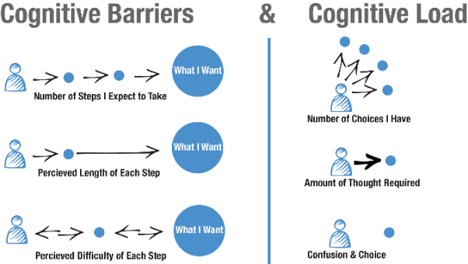





https://uxdesign.cc/the-application-of-cogntive-psychology-to-user-interface-design-81599ad7fb55

(b) Some interfaces/displays are hard to interpret *(e.g. it is confusing or difficult to comprehend).* Find 2 examples of such interface and bring it to the classroom. ***The 2* *examples must be of websites/software developed by Malaysian companies only.*** Point out which part(s) of the interfaces/displays that are hard to interpret/confusing/difficult to comprehend. Explain your answer. Note: Use PowerPoint slides to show the 2 examples. Recommend how the problems can be solved.

<http://www.imi.gov.my/index.php/en/>

**Problem**: Too dense, too much information section is scrolling continuously, unclear of section

**Possible solution**: Simplify information. Make use of white space to separate sections.

<http://www.malaysia.gov.my/en/home>

**Problem**: Too many colours, confusing, too many animations, motions sliding in and out irritating to eye, lack of grouping of information.

**Fixes**: More even colour, no sliding picture,

## Question 2

1. Visit the link below and then carry out the following activities:

<http://architectingusability.com/2011/05/26/using-the-gestalt-laws-of-perception-in-ui-design/>

Prepare PowerPoint slides with brief notes and examples and then teach the class the following 2 laws - Law of proximity

### - Law of similarity

**Proximity**: We tend to group things that are close together as one. Eg. labels and textbox.

Placing related elements in close proximity and using whitespace to create meaningful groups is a foundational principle in visual design. Users are task-focused and may scan pages quite quickly, so making these groupings visually obvious increases usability by helping users quickly find and focus only on those UI elements that are most related to their current task.

<https://www.nngroup.com/articles/gestalt-proximity/>

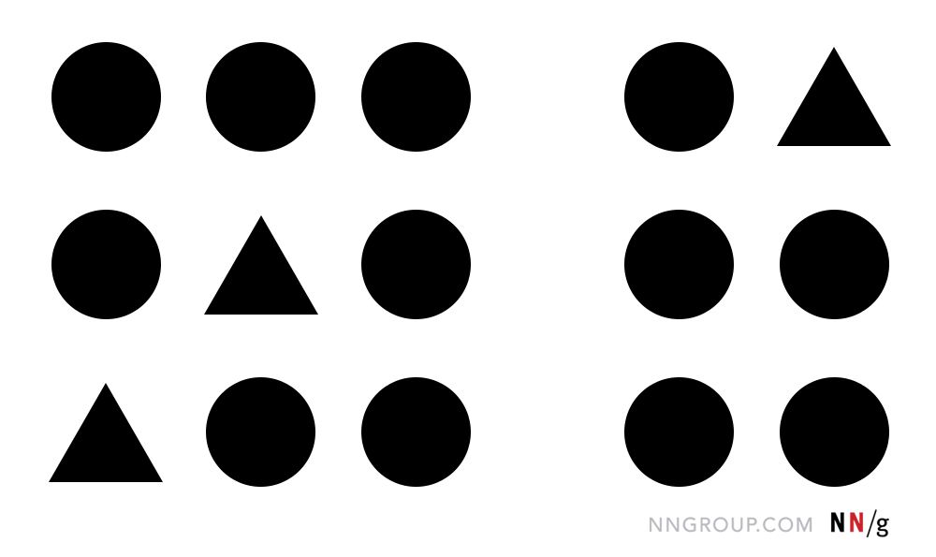

Group 2

Group 1

Spaces make a difference the here

**Similarity**: We perceive things that looks similar as one. Eg. When sorting files with files icons. Or sharing similar background to use it as grouping in label and text field.

<https://www.nngroup.com/articles/gestalt-similarity/>

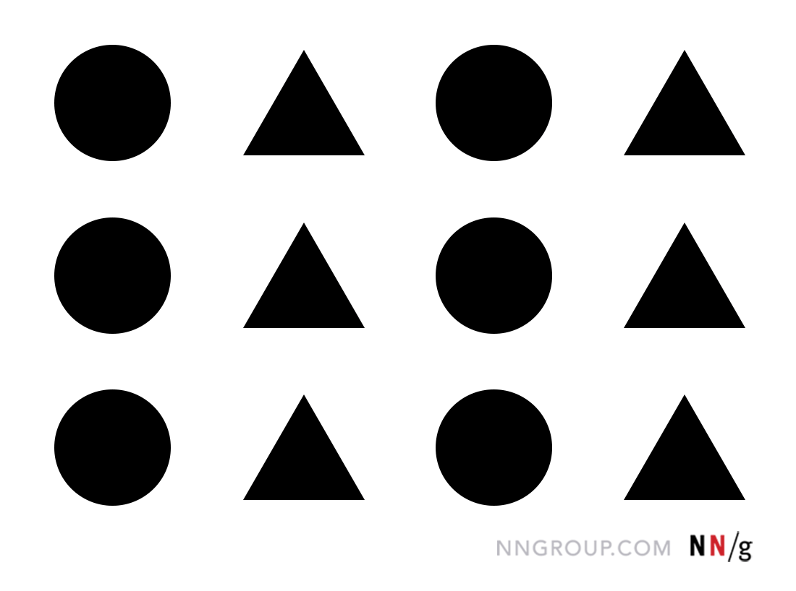

We tend to perceived this image has 4 columns based on the similarity of the shapes that are grouped together.

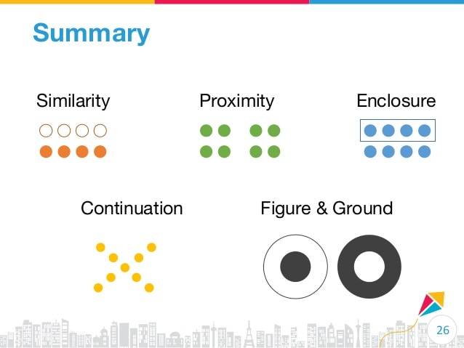

Right circle seems bigger than left circles, actually both same size

1. Comment the 2 figures below in terms of its *figure(foreground)* and *ground(background).*

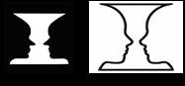(hints: using your favourite browser search for the subject “**figure and ground**” for more information).

It is hard to see or differentiate the vase and faces at the same time. Ground should support the figure so that the object can be viewed easily. In UI, the ground should be less prominent than the figure.

Figure at the back if you look at the left image the black background colour already covers the white vase, psychologically, our perception, I also see two human faces each other’s.

In the right figure, the white background colour, vase also use same background colour make it very hard for me to distinguish between FG and BG.

Imagine if these sorts of things happen in washroom icon, we can’t differentiate male and female washroom.

1. “For UI design, the *ground(background)* of the UI should be designed in such a way that it supports the *figure(foreground)*.” Do you agree with this statement? Explain your answer.

Yes, to avoid the confusion to the user, as you can see in the above examples. The user cannot even differentiate the object either as vase or face.



## Question 3

(a) Identify the 3 common applications of sounds. State which 2 are the most commonly used in HCI. Give 2 examples **(*own examples*)** and elaborate your answer.

Locate things, provide feedback and attract attention. Eg. Microwave oven, ding sounds, washing machine, beep sound, air conditioner, turn on /off, car sensors (near obstacles high tone beep sounds)

(b) Give 2 examples of systems **(*own examples*)** that should use sound for *FEEDBACK* and/or *ATTRACTING* attention but unfortunately currently it is not using it. Justify your answer.

Electric kettle (water is boiled already, no sounds), coffee vending machine (out of stock, full already)